St James Township, Beaver Island MI
Township Board Financial Report for October 11, 2022
Fiscal Year 22 (April 1, 2022 – March 31, 2023)
October Report: 7th month/12 = 58% of year elapsed

Charlevoix State Bank Account Balances
and Revenues and Expense Report
Account | Last Month  10/31/22 | Previous Mo.  9/30/22 | Last Year  10/31/21 | To-Date  Revenues  10/11/22 | To-Date Expenses  10/10/22
General Fund | $72,382.50 | $102,015.72 | $246,227.58 | $254,545.26 | $479,009.55
Municipal Dock | $103,274.22 | $155,820.67 | $158,690.50 | $244,315.79 | $246,036.89
Sewer Use | $31,983.14 | $29,828.06 | $14,473.56 | $27,348.50 | $12,367.93
Sewer Cap. Impr.* | $17,098.64 | $17,094.33 | $7,085.55 | NA | NA
Street & Road | $366,225.64 | $366,860.70 | $291,361.53 | $8,394.23 | $17,747.27
Lighthouse | $5,443.72 | $5,442.35 | $5,587.79 | NA | NA
Reserve* | $75,066.81 | $75,066.81 | NA
*The Sewer Capital Improvement and Reserve funds only reports quarterly, so the nearest quarter information is reported herein

Account Notes
Account | Monthly Highlights
General Fund: | The majority of this account’s funds are from property taxes and grants not involving the below accounts. Large expenses relative to one-time costs of returning an overpayment of ARPA funds ($60,136), purchasing the new township pickup, snowblade, and trailer (over $40,000), as well as costs associated with re-roofing the Deputy Residence ($26,400) have affected this fund. Other than those expenses, payroll remains the greatest expense for the township with greater hours worked during the summer months.  Additional revenues are expected, these include: $216,601 in winter taxes and $49,489.36 from the State for the Campground and transfer of general fund costs incurred via the Dock or Sewer funded work.
Municipal Dock: | This enterprise fund (no millage) is in good shape. More detailed financial information will be provided in a later scheduled Board Packet. The repair of the floating docks may not be covered by insurance (wind damage not water damage is covered).
Sewer Use: | This enterprise fund (no millage) does not receive tax dollars. Sewer users continue to pay in a timely manner. Annual sewer study will be completed in November. The final pumping cost was $17,220 for 22,800 gallons.
Sewer Capital Improvement: | This enterprise fund (no millage) was set up to save money for capital improvement projects related to the sanitary sewer.
Street & Road: | This millage-based account is stable; however, the every-three-year purchase of gravel ($131,160 in 2022) will reduce any surpluses as will any township-based road improvement.  $144,000 is to be paid for the gravel costs and two dust control applications.
Lighthouse: | This fund is set up to save money for improvements to the Whiskey Point Lighthouse. Funds come from 50% of the donations during summer tours sponsored by BIHS. Painting the tower needs to be assessed.
Other Monthly Notes: A second page is added to this report which gives board members a snapshot of Charlevoix State Bank funds on the day the snapshot was taken (not the end of the previous month).
c:\users\st james twp\documents\finance\monthly board reports\2022\monthlyfinancereport11_November.2022.docx

Charlevoix State Bank
St James Township Balances as of November 11, 2022

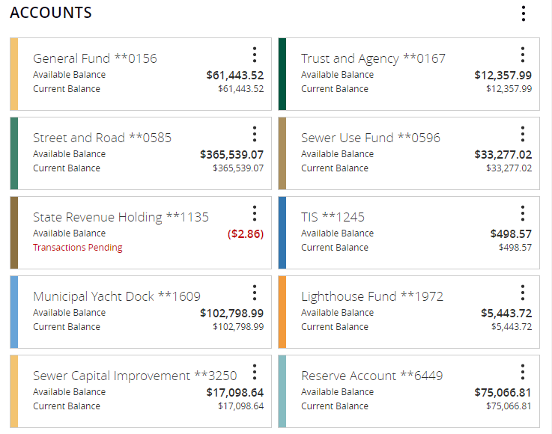
IMPORTANT NOTES:
- The Gravel Production Cost for the township is $131,160, though $129,xxx was invoiced.
- The Trust & Agency Account is simply a pass-through account for tax dollars received and awaiting transfer to receiving taxing unit.
- The State Revenue Holding Account shows dollars coming from the state and other sources, awaiting transfer to receiving township fund.

